PS-Lab sheet 5

1)

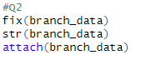2)

3)

4)

